Project title: - IFA2 (Interconnection France Angleterre) Durkin value £10m

The Challenge
It is crucial that European countries become and remain self sufficient in the provision of electrical energy to fuel the needs of industry commercial and domestic users. The UK is an island nation meaning that even with self sufficiency there is a risk to what is an island network.

How does the UK build in resilience and security to our ever-increasing energy demands?

Subsea Cable links will continue to play a significant role in moving UK secure energy to demand centres, and supporting the net carbon zero position by 2050.

Traditionally, energy networks were designed to distribute the stable outputs of certain number of coal-fired, gas or nuclear power plants. The birth of wind and solar centres has changed this geography and created a need to shift energy around.

Schemes such as the North Sea Link between Norway and the UK, allow sharing of Norwegian Hydro produced energy and UK Wind Energy between the two grid systems.

IFA 2
IFA 2 is one of a series of interconnection project to shift energy. Undertaken jointly by UK and France; in the case of IFA 2 the route uses a 200km subsea route with a far shorter land section.

The interlink comprises two separate circuits operating at 400kV routed across the English Channel to make landfall at the Port of Solent Hampshire. Further land and sea sections in the UK require cable schemes to provide connection to National Grid network at Chilling 400kV national grid site Hampshire, via a converter station sited at Daedalus airport.

Offshore
installation along the route in the Channel was completed in four different sections by Prysmian’s cable-laying vessel Cable Enterprise. For half of the length, the seabed was jettable and the cable was buried by a high-pressure jet of water from Prysmian’s Sea Mole jetting tool. For the remaining rocky sections, Prysmian relied on other special trenching equipment.

Onshore
The converter station in the UK is near the Solent Airport in Hampshire, which meant the cable had to cross the airfield, creating a set of logistical considerations, and requiring special planning. Height restrictions at the landfall interface with the operational runway and limited cranes & jack up barges, to say the least.

The project also called for the install of cables for an approximately ten-km route in the UK, linking two substations on the coast with an offshore cable. This area called for special attention to protect the environment of wildlife including badgers, dormice, and birds.
‘’Quality performance, and project management standards had to reach the highest level on the market to meet our client’s expectations.” Commented Mike Durkin CEO.

Technically the landside install required a contractor with sound in depth knowledge of 400kV cable installations.

Not surprising therefore that Prysmian who were the cable manufacturer and principal contractor, turned to Durkin and Sons, entrusting to them the landside section. Durkin already had an enviable pedigree in transmission cable install for major network and Interlinks projects.

Durkin and Sons Responsibilities
  - Construct a route 2km in length across Daeadalus airfield for the two DC cables which included the Terminal joint bay (TJB) intermediate bay as well as the fully ducted route. The laying of the DC cables from TJB to Converter station terminations.
  - A parallel route 2km long at Daedalus for the double circuit 400kV AC cables from the Converter compound back to two number TJB including all civils and cable installation.
  - A further 2.5km AC route comprising 400kV double circuit from the TJBs to GIS at Chilling Terminal compound.
  - All landside enabling works and compound provisions

Durkin appointment

- Contractor for all UK Landside off site route sections
- All route proving
- All excavation
- Joint bay construction
- Duct laying
- Cable Laying
- Permanent reinstatement
- Provision of detailed as built cable records
- Provision of NGC authorised/accredited staff

Challenges

- Live airside working environment
- Low Level Fencing with Lighting to Meet Airfield Regulations
- Excavations Closed Each Day – No Open Trench Exposure to Aircraft
- No Spoil on Site all Removed to Depot Store
- New Materials Brought to Site Only When Needed
- Safety and Operation of Airfield took Precedence
- Mix of ground conditions from Beach side through to taxiways

The landside cable install was completed to programme and energised successfully for the first time in 2022. This important project provides 1GW of power enough to supply up to a million homes, key to its success were the expertise delivered by Durkin and Sons coupled with the great team from Prysmian and National Grid.

Contact Details

Durkin and Sons Ltd
1 Phoenix trading estate
Perivale
UB6 7DZ

WWW.Durkinandsons.co.uk

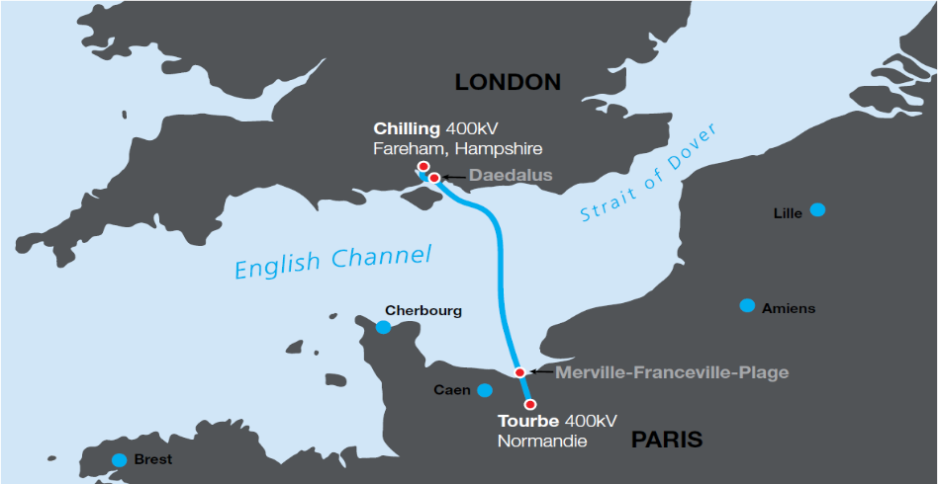

.

IFA 2 UK Land – Daedalus Route Section
